Four Marks C of E Primary School - Letter Formation in Reception
In Reception we teach pre-cursive letter formation. This means we include a lead-in (or ‘whoosh’) from the line at the start of each letter. We also include a lead-out (or ‘flick’) where appropriate, such as for the letters b and p. Your child will learn a mnemonic for the formation of each letter, as you can see below.
The mnemonics are based on the Read, Write Inc. pictures and so we have included these for your reference.
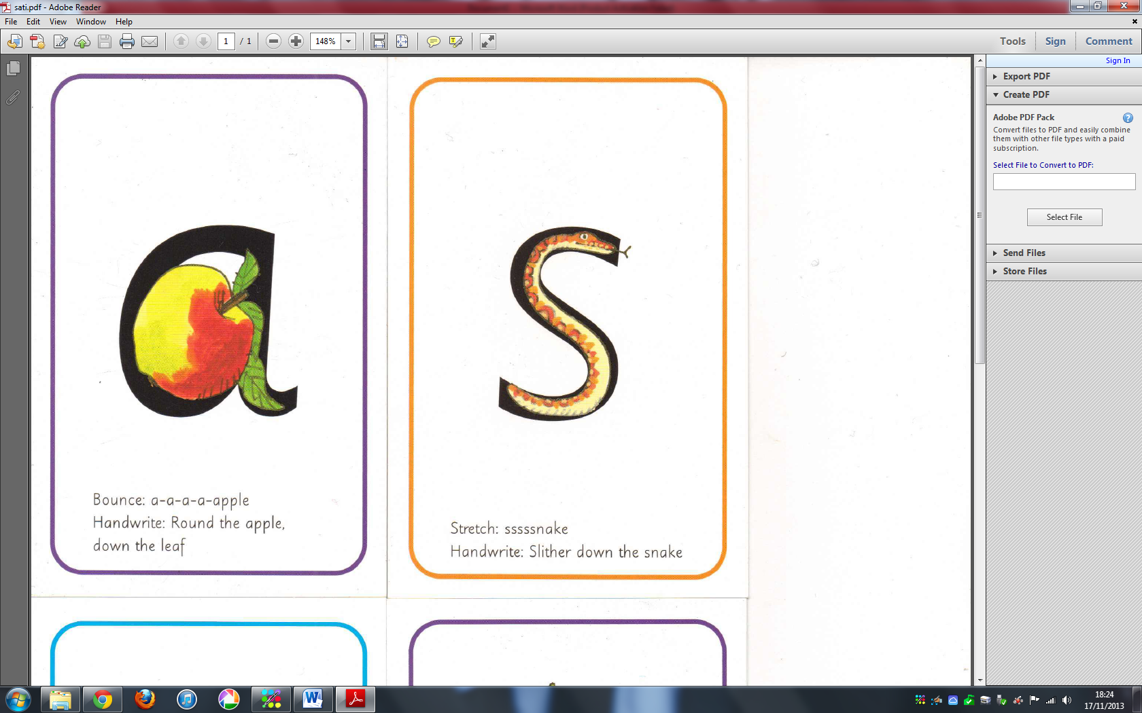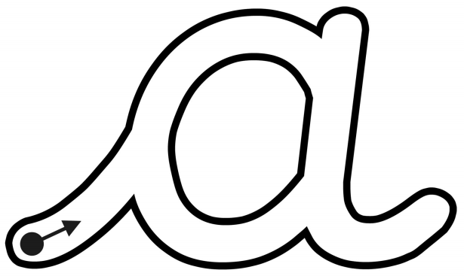  a-a-a-a-apple  Whoosh, round the apple, down the leaf and flick. | 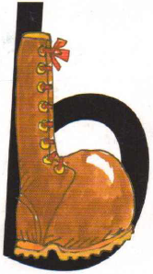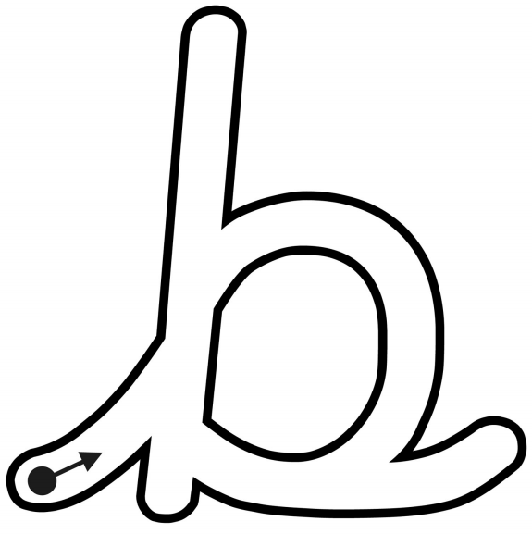  b-b-b-boot  Whoosh up, down the laces to the heel, round the toe and flick. | 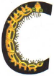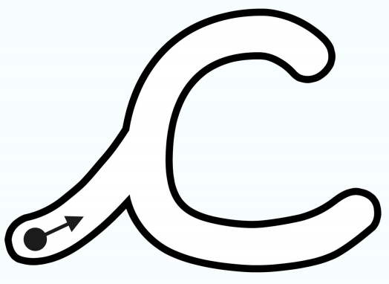  c-c-c-caterpillar  Whoosh, curl around the caterpillar. | 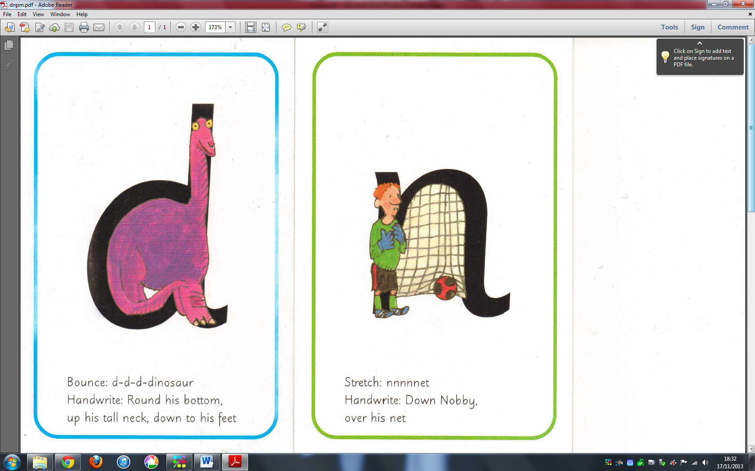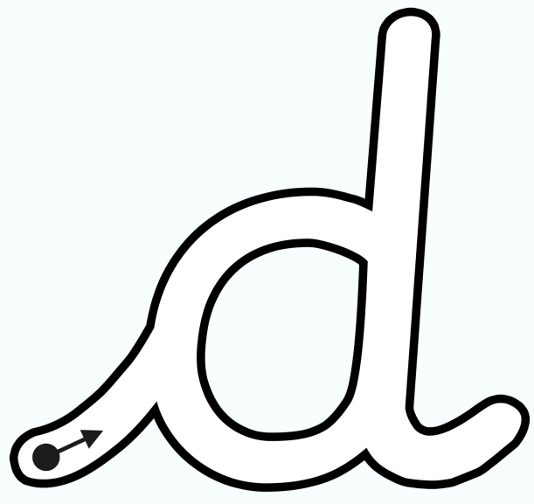  d-d-d-dinosaur  Whoosh, round his bottom, up his tall neck, down to his feet and flick. | 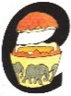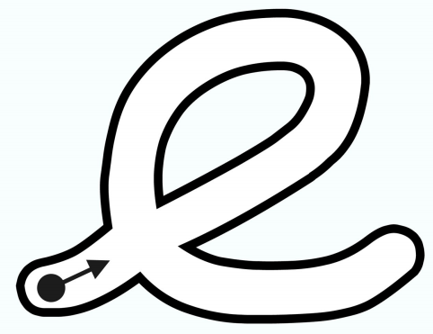  e-e-e-egg  Whoosh, lift off the top and scoop out the egg. | 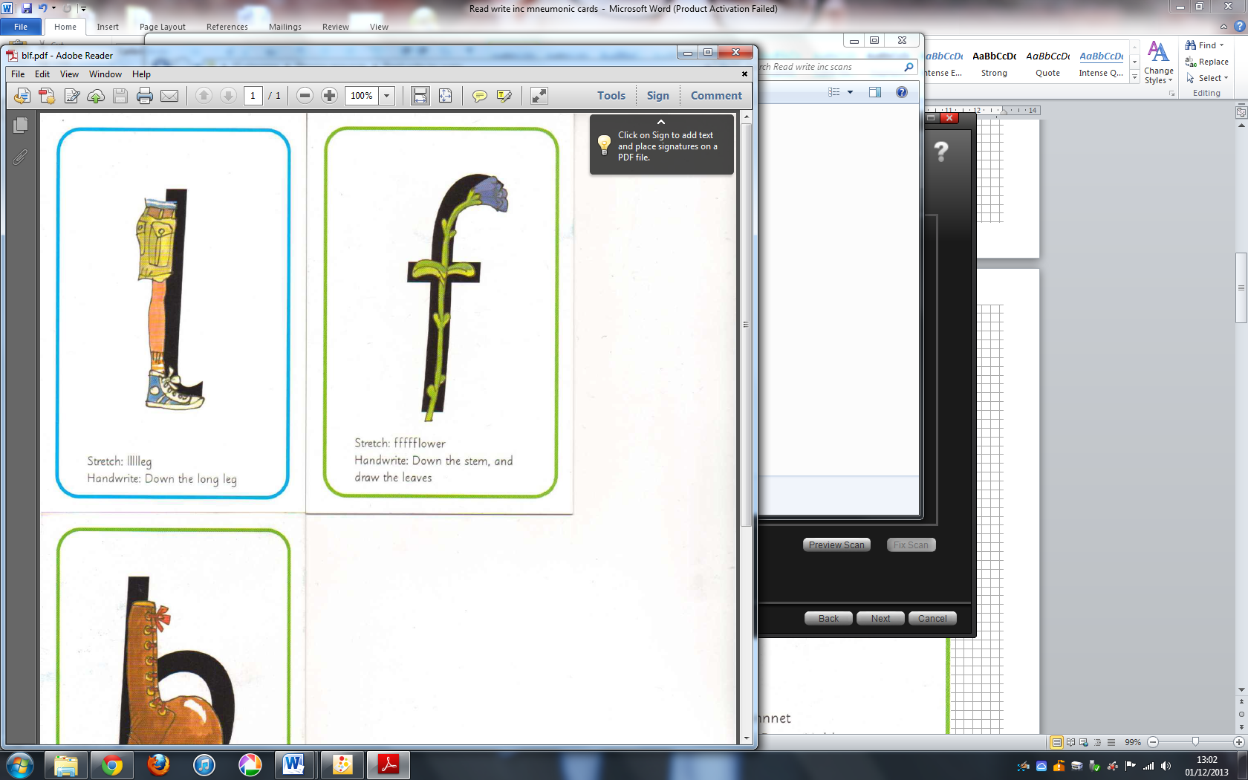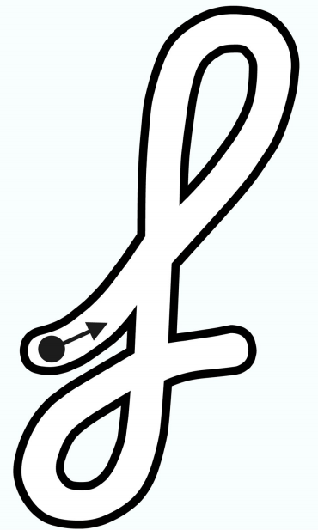  ffffflower  Whoosh, down the stem and draw a leaf. | 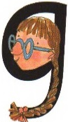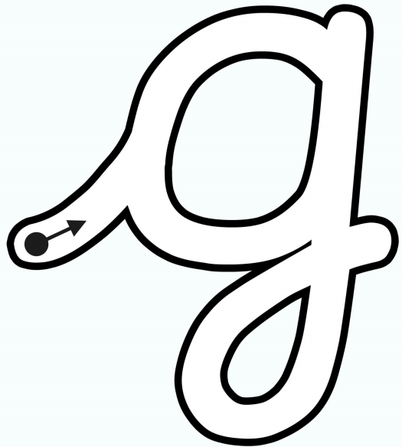  g-g-g-girl  Whoosh, round her face and give her a curl.
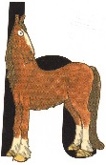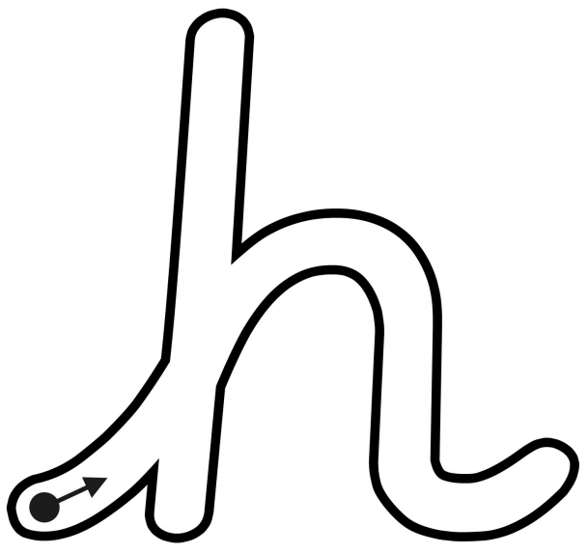  h-h-h-horse  Whoosh up, down the head to the hooves, over his back and flick. | 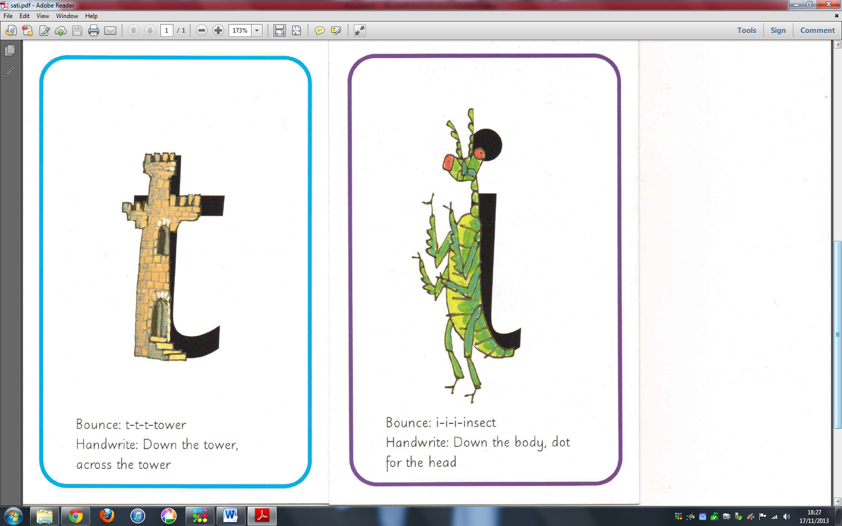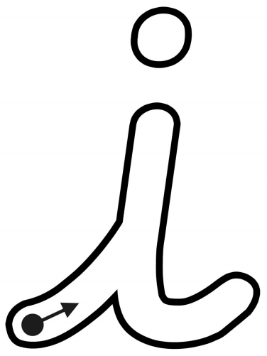  i-i-i-insect  Whoosh up, down the body, flick and a dot for the head. | 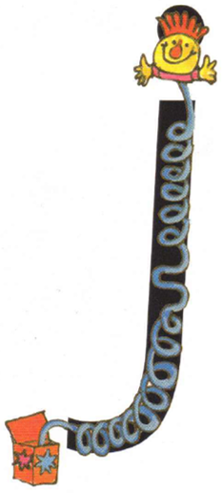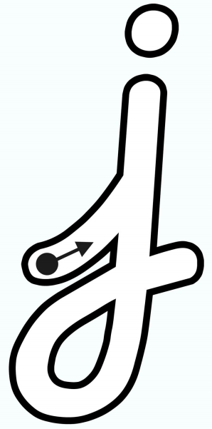  j-j-j-jack-in-a-box  Whoosh up, down his body, curl and a dot for the head. | 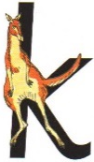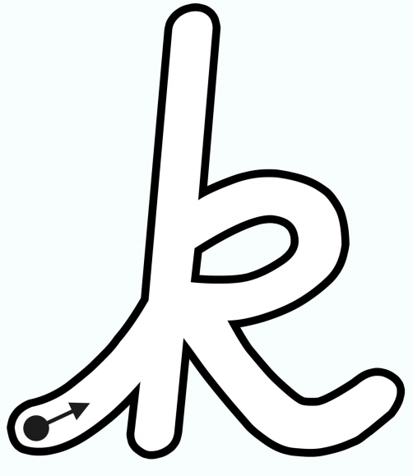  k-k-k-kangaroo  Whoosh up, down the kangaroo’s body, back up, round his arm, down his leg and flick. | 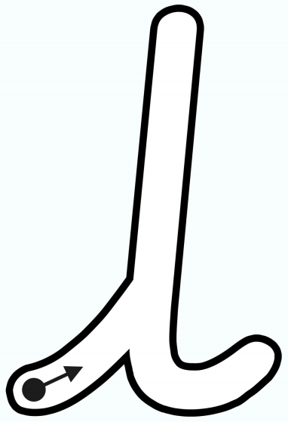  llllleg  Whoosh up, down the long leg and flick. | 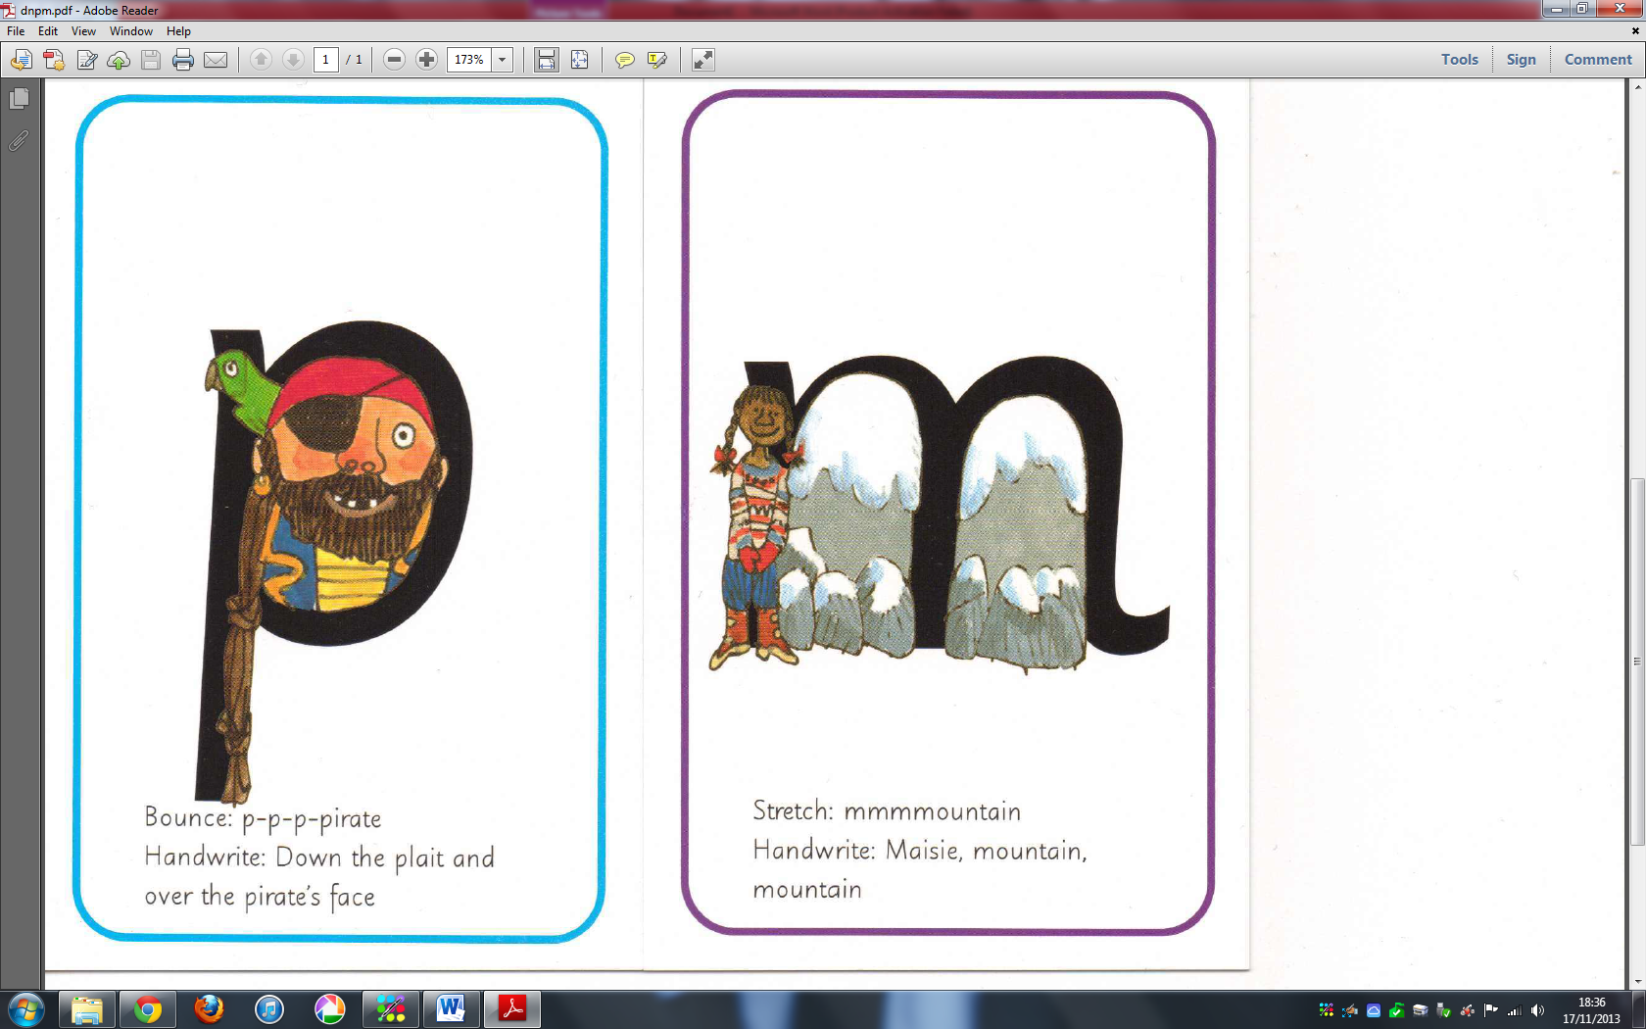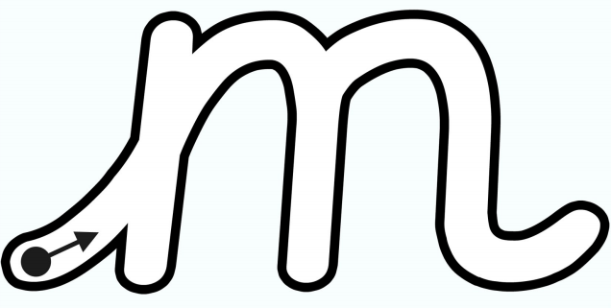  mmmmmountain  Whoosh up, Maisie, mountain, mountain and flick. | 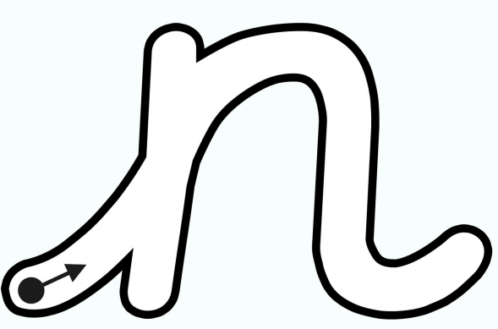  nnnnnet  Whoosh up, down Nobby, over his net and flick.
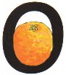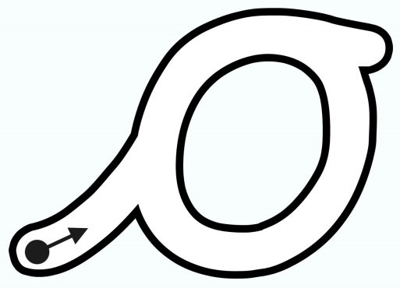  o-o-o-orange  Whoosh, all around the orange and flick. | 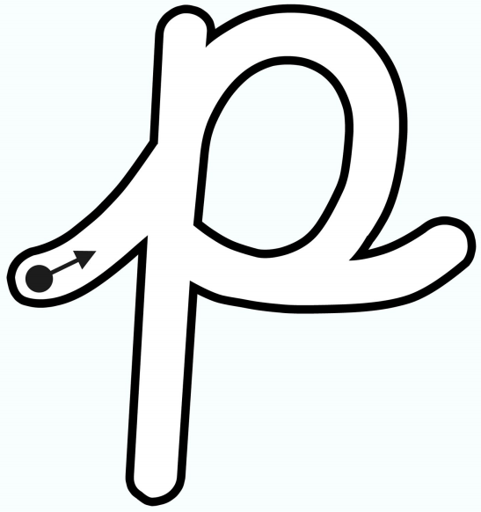  p-p-p-pirate  Whoosh up, down the plait, up, over the pirate’s face and flick. | 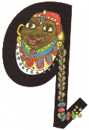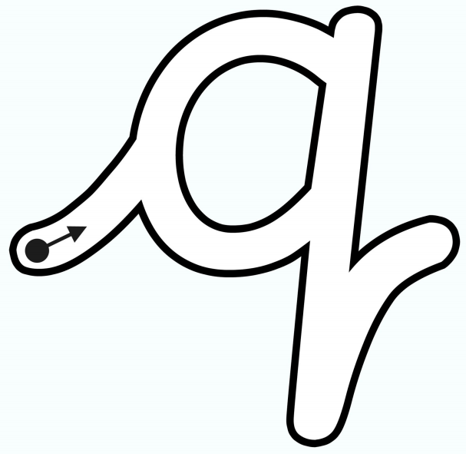  qu-qu-qu-queen  Whoosh, round her head, up past her earrings, down her hair and flick. | 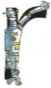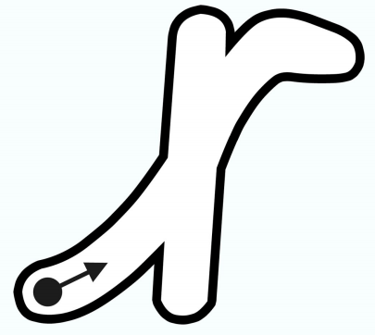  rrrrrobot  Whoosh up, down his back, then curl over his arm. | 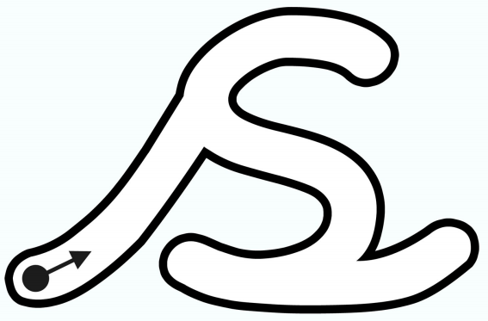  sssssnake  Whoosh, slither down the snake and flick. | 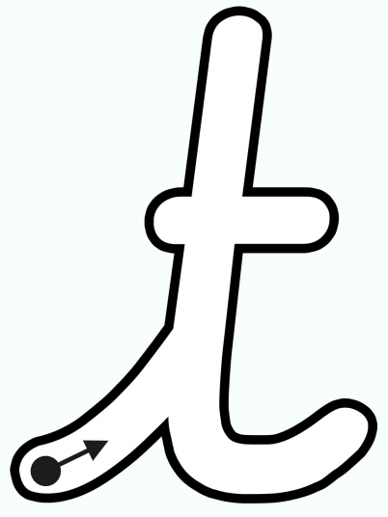  t-t-t-tower  Whoosh up, down the tower, across the tower. | 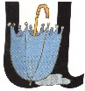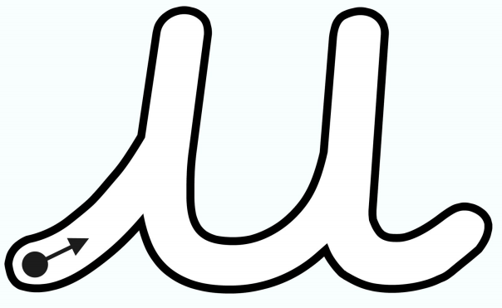  u-u-u-umbrella  Whoosh up, down and under, up to the top, draw the puddle and flick.
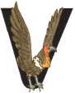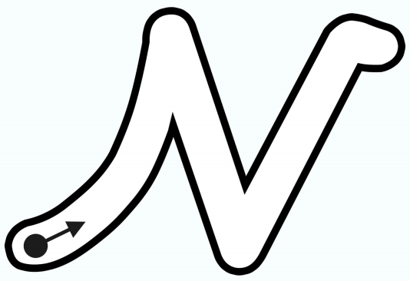  vvvvvulture  Whoosh, down a wing, up a wing and flick. | 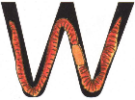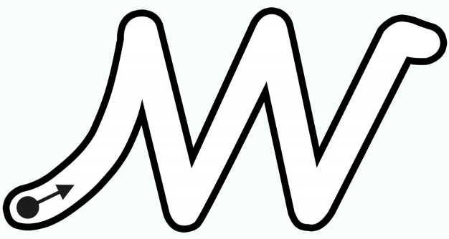  w-w-w-worm  Whoosh up, down, up, down, up and flick. | 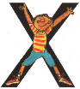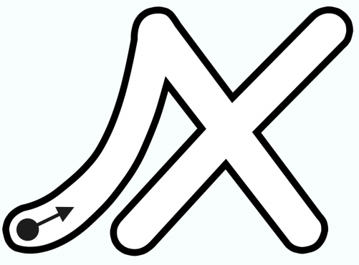  x-x-x-exercise  Whoosh up, down the arm and leg and repeat the other side. | 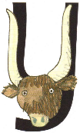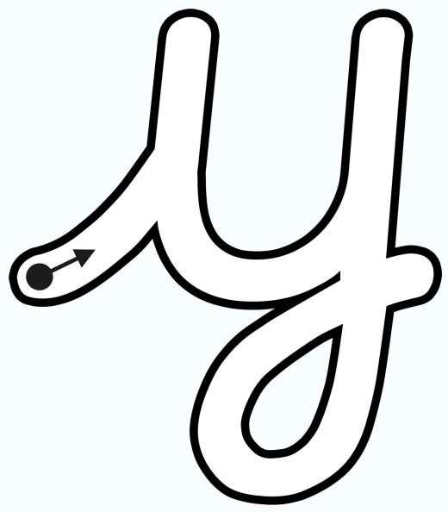  y-y-y-yak  Whoosh up, down a horn, up a horn and under his head. | 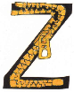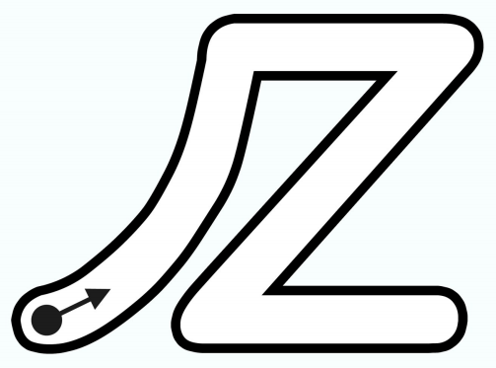  zzzzzip  Whoosh, zig-zag-zig.

