Four Marks CE Primary School
Relationships, Sex and Health Education Policy (2020)

Approved by: | Governors | Date:
Last reviewed: March 2026
Next review due by: March 2029
Contents: |  |  | Page Number
Vision & Christian Values  1. Aims  2. Statutory Requirements  3. Policy Development  4. Definition  5. Curriculum  6. Delivery of RSE  7. Inclusion  8. Roles and responsibilities  9. Parents’ right to withdraw  10. Training  11.Monitoring arrangements  Appendices:  Appendix 1:  PSHE (&RSE) Curriculum Map- Expectations  Appendix 2: Long Term Curriculum Map  Appendix 3: Additional Reference Links |  |  | 2  2  2  2  2  3  3  4  5  5  6  6  7  8  10

Vision and Values

Our School aims to be a loving, inclusive family where our core Christian Values of Love, Integrity, Forgiveness and Equality (LIFE) are recognised and developed. With God's love, all are encouraged to thrive, as we learn to walk in Jesus's footsteps.
As a Christian School Community, we believe that the ethos of our school should be built on a foundation of core Christian Values. The staff, children and governors have agreed the following four core values that we feel support our school motto which is ‘To prepare children for life’:

Love
Integrity
Forgiveness, and
Equality
which will be promoted in school.

These core values will help us sustain an ethos which supports our aim for children to live happy, safe, healthy and fulfilling lives, to become confident individuals and responsible citizens who make a positive contribution to society.

We hope that our core values will help children understand that there are some central beliefs that people hold, and learn to fall back on these when making choices and decisions using these core values as an important guiding tool.

1. Aims
We undertake to follow the principles in the Church of England Charter for faith sensitive and inclusive relationships education, relationships and sex education (RSE) and health education (RSHE).
The aims of our relationships, sex and health education (RSHE) curriculum are to:
- Enable children to understand how to keep themselves and others safe, including online
- Develop the personal skills needed by pupils for them to establish and maintain relationships, to recognise what a healthy relationship looks like, to form healthy relationships, ensuring respect and dignity for themselves and others
- Explore how to live well together, including behaving well towards others, disagreeing well, forgiving and repairing broken relationships
- Develop the skills to express their own views and make their own informed decisions, providing a framework in which sensitive discussions can take place
- Help pupils develop feelings of self-worth, self-respect, confidence and empathy, to cherish themselves and others as unique and wonderfully made
- Create a positive culture around issues of sexuality and relationships
- Teach pupils the correct vocabulary to describe themselves and their bodies
- Prepare pupils for puberty, by giving them an understanding of the importance of health and hygiene
- Enable children to make responsible and informed decisions to support their physical health, mental health and wellbeing
- Teach children to recognise and regulate their emotions in positive ways, including understanding the neuroscience behind their behaviours
- Provide opportunities for children to be taught and to discuss all content in an age-appropriate way

2. Statutory requirements
As a primary school, we must provide relationships education to all pupils as per section 34 of the Children and Social work act 2017. We are required to follow the National Curriculum including requirements to teach science which would include the elements of sex education contained in the science curriculum. In teaching RSE, we are required to have regard to guidance issued by the secretary of state as outlined in section 403 of the Education Act 1996. At Four Marks Primary School we teach RSE as set out in this policy.

3. Policy development
This policy has been developed in consultation with staff, pupils and parents. The consultation and policy development process involved the following steps:
- Review –The PSHE lead pulled together all relevant information including relevant national and local guidance
- Staff consultation – all school staff were given the opportunity to look at the policy and make recommendations
- Governor consultation- this included wider reading around RSE, the equality act, and debate around the Church of England’s guidance documents. Governors also had focused training from the Diocese on ‘Equalities’ in 2019.
- Parent/stakeholder consultation – The policy was made available to parents on the website for two weeks and they were invited to discuss any points
- Ratification – once amendments were made, the policy was shared with governors and ratified

4. Definition
RSHE is about the emotional, social and cultural development of pupils, and involves learning about relationships, sexual health, sexuality, healthy lifestyles, diversity and personal identity. RSHE involves a combination of sharing information and exploring issues and values. RSHE is not about the promotion of sexual activity.

5. Curriculum
At Four Marks Primary School, RSE is delivered within the personal, social, health and economic (PSHE) education curriculum. It also compliments content covered in Science, Computing and PE, and other aspects are included within religious education (RE).
We have developed the curriculum in consultation with parents, pupils and staff, considering the age, needs and feelings of pupils. This will be reviewed and adapted as and when necessary to meet the changing needs of our children.
Our curriculum content is based on resources provided by the PSHE association, supplemented by additional resources. Teachers will use the objectives and always take into account the needs and feelings of our pupils.
If pupils ask questions outside the scope of this policy, teachers will respond in an appropriate manner so they are fully informed and don’t seek answers online. In some cases, we may discuss the question with the parents so they can decide which information is age-appropriate for their child.
Appendix 1 shows how our PSHE curriculum covers all the strands of the statutory guidance. All areas related to relationships, sex and health are statutory, apart from the specific teaching of sex education in years 5 and 6.

Primary sex education (non-statutory) will focus on:
- Preparing boys and girls for the changes that adolescence brings
- How a baby is conceived and born
For more information about our curriculum, see our curriculum map in Appendix 1.

Relationships education (statutory) focuses on teaching the fundamental building blocks and characteristics of positive relationships including:
- Families and people who care for me
- Caring friendships
- Respectful relationships
- Online relationships
- Being safe
Our school follows the Christopher Winter Project resource (endorsed by the PSHE Association) to deliver the non-statutory element of the RSHE curriculum. For more information about our RSHE curriculum, see Appendices 1 and 2. These areas of learning are taught within the context of family life taking care to ensure that there is no stigmatisation of children based on their home circumstances (families can include single parent families, LGBT parents, families headed by grandparents, adoptive parents, foster parents/carers amongst other structures) along with reflecting sensitively that some children may have a different structure of support around them (for example: looked after children or young carers).

6. Inclusion

Equality

Four Marks CE Primary School is an inclusive school where we place a strong focus on the wellbeing and progress of every child and where all members of our community are of equal worth

Schools have a legal duty to promote equality (Equality Act, 2010) and to combat bullying (Education Act, 2006) (which includes homophobic, sexist, sexual and transphobic bullying) and Section 4.2 of the national curriculum (2014) states “Teachers should take account of their duties under equal opportunities legislation that covers race, disability, sex, religion or belief, sexual orientation, pregnancy and maternity, and gender reassignment.”
RSE has clear links with other school policies aimed at promoting pupils’ spiritual, moral, social and cultural development, including the:
- Anti-Bullying Policy
- Behaviour Policy
- Confidentiality Policy
- Equality and objectives Policy
- Health and Safety Policy
- Computing Policy and E Safety Policy
- RE Policy
- Safeguarding/Child Protection Policy
- SMSC Policy
- Special Educational Needs Policy

SEND
At Four Marks Primary School Relationships and Health Education is accessible for all pupils. We provide high quality teaching that is differentiated and personalised to ensure accessibility.

7. Roles and responsibilities
The Governing body
The governing body has delegated the approval of this policy to The Standards and Curriculum Committee and it will hold the Headteacher to account for the implementation of this policy.
The Headteacher
The Headteacher is responsible for ensuring that RSHE is taught consistently across the school, and for discussing any concerns or issues parents may have.
The Curriculum Leader
The Curriculum Leader will:
- develop a differentiated curriculum;
- work closely with subject coordinators in Science, Computing, R.E and P.E. to ensure Relationships Education, Sex Education and Health Education do not duplicate content covered in the National Curriculum;
- work with external organisations in order to enhance delivery of these subjects by introducing specialist knowledge and different ways of engaging with pupils;
- ensure that the teaching delivered by a specialist teacher fits with the planned programme;
- provide strategic leadership and direction;
- provide a curriculum that provides pupils with the essential knowledge they need to be educated citizens in democratic Britain;
- coordinate a number of working parties in order to explore ways of improving the curriculum and the way in which we deliver it;
- promote an awareness of and respect for a diversity of cultures, values, beliefs and abilities;
- ensure appropriate coverage of the curriculum;
- provide support and advice;
- monitor pupil progress in this area;
- ensure sufficient and up to date resources are in place
- provide guidance and support to all staff;
- provide training for all staff on induction and when the need arises regarding;
- make effective use of relevant research and information to improve this policy;
- keep up to date with new developments and resources;
- undertake risk assessments when required;
- review and monitor the implementation of the policy and curriculum;
- annually report to the Governing Body on the success and development of this policy
Staff
Staff are responsible for:
- Delivering RSHE in a sensitive way
- Modelling positive attitudes to RSHE
- Monitoring progress
- Responding to the needs of individual pupils
Staff do not have the right to opt out of teaching RSE. Staff who have concerns about teaching RSE are encouraged to discuss this with the Headteacher.
Pupils
Pupils are expected to engage fully in RSE and, when discussing issues related to RSE, treat others with respect and sensitivity.

8. Parents’ right to withdraw
Parents do not have the right to withdraw their children from relationships education. Parents only have the right to withdraw their children from the non-statutory/non-science components of sex education within RSHE. Requests for withdrawal should be put in writing and addressed to the Headteacher. Alternative work will be given to pupils who are withdrawn from sex education.

9. Training
Staff are trained on the delivery of RSHE as part of their induction and it is included in our continuing professional development calendar. The Headteacher will also invite visitors from outside the school, such as school nurses or sexual health professionals, to provide support and training to staff teaching RSHE.

10. Monitoring arrangements
The delivery of RSHE is monitored by the Lead for PSHE, Phase Leaders and the Headteacher through: Learning Walks, child conferencing/ pupil voice and work sampling.
Pupils’ development in RSHE is monitored by class teachers as part of our internal assessment systems.
This policy will be reviewed by PSHE lead and the Curriculum and Standards committee on a bi-annual basis or in the event of updated statutory guidance. At every review, the policy will be approved by Governing Board.

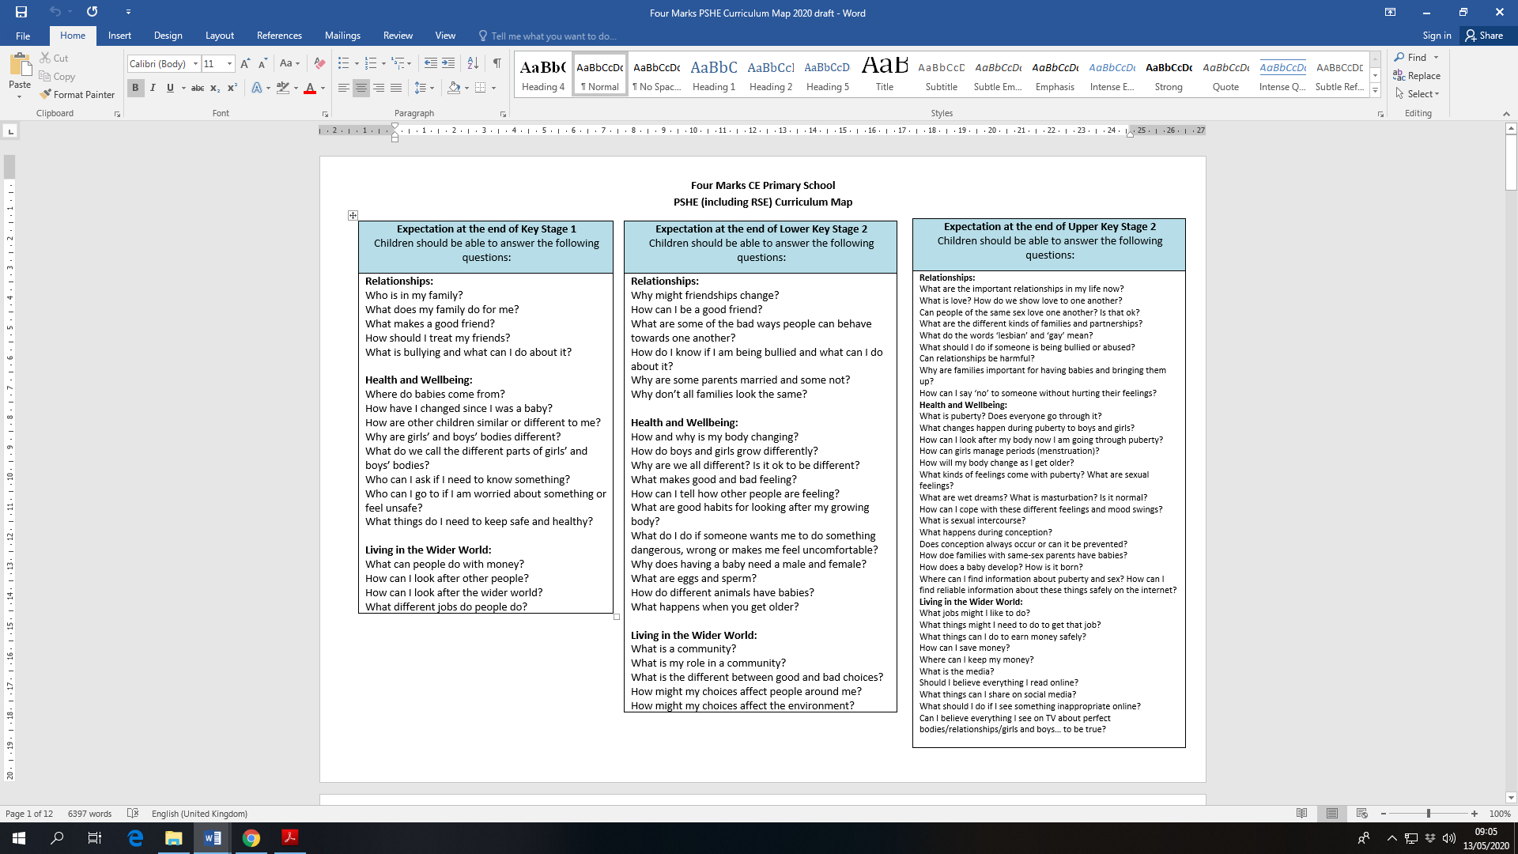
Appendix 2: Whole School Long Term Curriculum Map
Appendix 1: Curriculum Map- Expectations
Cycle A
 | Autumn | Autumn 2 | Spring 1 | Spring 2 | Summer 1 |  | Summer 2
Foundation Stage | Relationships: Who is my family?  CWP: Reception – Lesson 3  No outsiders text: The Family Book | Relationships: How do I make friends and look after my friends?  No outsiders text: Blue Chameleon | Relationships: Who keeps me safe?  No outsiders text: Mommy Mama and Me | Health and Wellbeing: How am I feeling?  No outsiders text: Red Rockets and Rainbow Jelly | Health and Wellbeing: How can I keep myself healthy?  CWP: Reception – Lesson 2 |  | Living in the wider world: What is my day like? How can I change my outdoor space?  CWP – Reception – Lesson 1  No outsiders text: You Choose
Key Stage 1 | Relationships: What is the same and what is different about us?  No outsiders text: Elmer | Relationships: Who is special to us?  CWP: Year 1 – Lesson 2  No outsiders text: Ten Little Pirates | Health and Wellbeing: What helps us stay healthy?  CWP: Year 1 – Lesson 1  No outsiders text: Max the Champion | Health and Wellbeing: What helps us to stay safe?  CWP: Year 2 – Lesson 3 |  | Health and Wellbeing: Who helps keep us safe?  CWP: Year 1 – Lesson 3  No outsiders text: My Grandpa is amazing | Living in the wider world: How can we look after each other and the wider world?  No outsiders text: My world, Your World
Key Stage 1 |  |  | Science: How animals survive  7 sessions
Lower Key Stage 2 | Relationships: How can we be a good friend?  No outsiders text: Oliver | Health and Wellbeing: Why should we eat well and look after our teeth? | Health and Wellbeing: What keeps us safe?  CWP: Year 3 – Lesson 2  No outsiders text: This Is Our House | Relationships: What are families like? CWPL Year 3 – Lesson 3  No outsiders text: Two Monsters |  | Living in the wider world: What makes a community?  No outsiders text: Beegu | Health and Wellbeing:  What strengths, skills and interests do we have?  No outsiders text: The Hueys in the New Jumper
Lower Key Stage 2 |  | Animals: Digestive system and teeth  7 sessions  CWP: Year 3 - Lesson 1
Upper Key Stage 2 | Health and Wellbeing: How can we keep healthy as we grow?  CWP: Year 5 – Lessons 1, 2 and 3  CWP: Year 6 – Lesson 1  (Consider splitting year group when teaching?)  No outsiders text: And Tango Makes Three |  | Health and Wellbeing: How can we help in an accident or emergency?  No outsiders text: How to Heal a Broken Wing | Relationships: How can friends communicate safely?  CWP: Year 6 – Lesson 4  No outsiders text: Rose Blanche |  | Health and Wellbeing: How can drugs common to everyday life affect health?  No outsiders text: The Whisperer | Living in the wider world: What jobs would we like?  No outsiders text: The Artist Who Painted a Blue Horse
Upper Key Stage 2 | Evolution, natural selection & Life Cycles  10 sessions
Relationships

Cycle B
 | Autumn 1 | Autumn 2 | Spring 1 | Spring 2 | Summer 1 | Summer 2
Foundation Stage | Relationships: Who is my family?  CWP: Reception – Lesson 3  No outsiders text: The Family Book | Relationships: How do I make friends and look after my friends?  No outsiders text: Blue Chameleon | Relationships: Who keeps me safe?  No outsiders text: Mommy Mama and Me | Health and Wellbeing: How am I feeling?  No outsiders text: Red Rockets and Rainbow Jelly | Health and Wellbeing: How can I keep myself healthy?  CWP: Reception – Lesson 2 | Living in the wider world: What is my day like? How can I change my outdoor space?  CWP – Reception – Lesson 1  No outsiders text: You Choose
Key Stage 1 | Relationships: What makes a good friend?  No outsiders text: The Great Big Book of Families | Relationships: What Is bullying?  CWP: Year 2 – Lesson 1  No outsiders text: The Odd Egg | Living in the wider world: What jobs do people do?  No outsiders text: The First Slodge | Living in the Wider World: What can we do with money? | Health and Wellbeing: What helps us grow and stay healthy?  No outsiders text: Blown Away | Health and Wellbeing: How do we recognise our feelings?  No outsiders text: Just Because
Key Stage 1 |  |  | Animals: Simple animal life time lines  5 sessions  CWP – Year 2 Lesson 2 (links to science) | Living in the Wider World: What can we do with money?
Lower Key Stage 2 | Relationships: How do we treat each other with respect?  No outsiders text: Dog’s Don’t Do Ballet | Health and Wellbeing: Why should we keep active and sleep well?  No outsiders text: Red: A Crayon’s Story | Health and Wellbeing: How can we manage our feelings?  No outsiders text: King and King | Health and Wellbeing:  How will we change and grow?  CWP: year 4 – Lessons 2 and 3  No outsiders text: The Flower | Health and Wellbeing: How can we manage risk in different places?  No outsiders text: The Way back Home |  | Living in the wider world: How can our choices make a difference to others and the environment?
Lower Key Stage 2 |  | Animals; Skeletons, muscles & movement  6 sessions |  |  | Plants: How plants reproduce  7 sessions  CWP: Year 4 – Lesson 1 |  | Feeding relationships & the environment  2 sessions
Upper Key Stage 2 | Health and Wellbeing: What makes up our identity?  No outsiders text: My Princess Boy | Living in the wider world: What decisions can people make with money?  No outsiders text: Dreams of Freedom | Living in the wider world: How can the media influence people?  No outsiders text: The Island |  | Relationships: What will change as we become more independent?  CWP: Year 6 – Lesson 2  No outsiders text: Where the Poppies Now Grow. |  |  | Relationships: How do friendships change as we grow?  CWP: Year 6 – Lesson 3  No outsiders text: Love You Forever
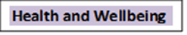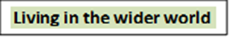
Appendix 3: Additional Reference Links

DFE Guidance – ‘Relationships Education, Relationships and Sex Education (RSE) and Health Education’ 2026. This guidance sets out legal duties with which schools must comply when teaching relationships education, RSE and health education.
https://www.gov.uk/government/publications/relationships-education-relationships-and-sex-education-rse-and-health-education

The Church of England Vision for Education – ‘Deeply Christian, Serving the Common Good’; Autumn 2016. Our church schools must be committed to being welcoming and inclusive communities where all feel included, can learn and flourish, living out Jesus’s promise of ‘life in all its fullness’ (John 10;10), regardless of their family arrangements, beliefs or sexual or gender orientation.
https://www.churchofengland.org/more/education-and-schools/vision-education

The Equality Act 2010. The Act protects people from discrimination and harassment. It places a duty on educational facilities to be proactive in considering the need to address inequalities.
http://www.legislation.gov.uk/ukpga/2010/15/contents

Flourishing for All. These resources address bullying in relation to protected characteristics.
https://www.nse.org.uk/curriculum-and-inclusion/inclusion-flourishing-for-all

Pastoral Principles for Living Well Together; Church of England; April 2019. These principles help shape the way we all relate to one another. The document can be found here:
https://www.churchofengland.org/sites/default/files/2019-02/PAG-PP-website.pdf

The Church of England’s Education Office publication, ‘RSHE Principles and Charter’ – This document explores the pastoral principles in more depth and how they relate to delivery of RSE in schools.
https://www.churchofengland.org/sites/default/files/2019-11///RSHE%20Principles%20and%20Charter_0.pdf

The Christopher Winter Project. Resources to support the teaching of relationships and sex education across the primary age range. https://www.teachsre.co.uk/rse-guidance-update

